Q1. (10+10= 20pts) (2013)
Consider a fully connected undirected graph G=<V,E> with n vertices where V={v₁,…, v_{n}} and 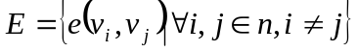! All edges have a weight w(v_{i},v_{j})=1).
- (9+3=12 pts)
Draw a MST that minimizes the weight sum between all pairs of vertices! Calculate the weight sum!
- (9+3=12 pts)
Draw a MST that maximizes the weight sum between all pairs of vertices! Calculate the weight sum!
Hint:
- The weight sum s(v_{i},v_{j}) between vertices v_{i} and v_{j} is the sum of the weights of the edges forming the path between v_{i} and v_{j}.
- The weight sum between all pairs of vertices is the sum S of all weight sums s(v_{i},v_{j}) for all i,j and i≠j
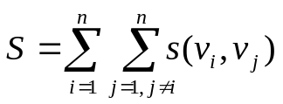

V1
Vi
V_{i-1}
V_{i+1}
Vn

An illustrative example:
V₅
V₁
V₂
V₄
V₃

We need to consider the weight sum s(v_{i},v_{j}) between V₁ (the center vertice) and the remaining vertices.
1,2:1
1,3:1
1,4:1
1,5:1
If we have n vertices then the total weight sum: (n-1)

We also have:
2,1:1
3,1:1
4,1:1
5,1:1
If we have n vertices then the total weight sum: (n-1)

If we have n vertices then the total weight sum: 2(n-1)

We also need to consider the weight sum s(v_{i},v_{j}) between the remaining vertices.
2,3:2
2,4:2
2,5:2
If we have n vertices then the total weight sum: (n-2)

3,2:2
3,4:2
3,5:2
If we have n vertices then the total weight sum: (n-2)

4,2:2
4,3:2
4,5:2
If we have n vertices then the total weight sum: (n-2)

5,2:2
5,3:2
5,4:2
If we have n vertices then the total weight sum: (n-2)

If we have n vertices, then: (n-1) (2(n-2))

The total weight is:

S=(2(n-2))(n-1)+2(n-1)=∈O(n²)
V1
V2
Vn

S =2[ n(n-1)/2 + (n-2)(n-1)/2+ (n-2)(n-3)/2+…+3*2/2+2*1/2]

1,2:1
1,3:2
1,4:3
1,5:4
..
1,n:n-1
The sum of integers between 1 and n-1 : (n-1)n/2

2,1:1
2,3:1,
2,4:2
2,5:3
…
2,n:n-2
The sum of integers between 1 and n-2 : ((n-2)(n-1)/2)+1

3,1:2
3,2:1,
3,4:1
3,5:2
…
3,n:n-3
The sum of integers between 1 and n-3 : ((n-3)(n-2)/2)+1+2

S=n(n-1)/2+(1+(n-2)(n-1)/2)+(1+2+(n-2)(n-3)/2) + (i(i+1)/2+(n-i)(n-i-1)/2) +…+ (n/2(n/2+1)/2+(n/2)(n/2-1)/2)=

Q2. ( 5 + 10 pts)(2007)
Consider the graph given in Fig. Q4! Starting from vertex 1, apply the depth-first search (DFS) algorithm that we talked in class
- list the vertices in the order they are visited in the DFS algorithm. The rule for visiting among neighbors is that a smaller numbered neighbor vertex is visited sooner.
- time-stamp the vertices in the figure as they are visited during the execution of the DFS algorithm.
7/18
88888
1000000000000000000000000000
9 9
33
444444
5 5
1 1
222222
666666666 66
777777
1/6
2/3
8/17
4/5
9/16
10/11
12/15
13/14
19/20
Figure Q4: The graph for question Q4
d/f



 | vertice | color | time | f | d
 | 1 | gray | 1 |  | 1
 | 2 | gray | 2 |  | 2
 | 2 | black | 3 | 3 | 2
 | 5 | gray | 4 |  | 4
 | 5 | black |  |  | 4
 | 1 | black |  | 6
 | 3 | gray | 7 |  | 7
 | 4 | gray | 8 |  | 8
 | 6 | gray | 9 |  | 9
 | 7 | gray | 10 |  | 10
 | 7 | black |  | 11
 | 8 | gray | 12 |  | 12
 | 10 | gray | 13 |  | 13
 | 10 | black |  | 14
 | 8 | black |  | 15
 | 6 | black |  | 16
 | 4 | black |  | 17
 | 3 | black |  | 18
 | 9 | black | 19 | 20 | 19

vertice | color | time | f | d
1 | black | 1 | 6 | 1
2 | black | 3 | 3 | 2
5 | black | 4 | 5 | 4
3 | black | 7 | 18 | 7
4 | black | 8 | 17 | 8
6 | black | 9 | 16 | 9
7 | black | 10 | 11 | 10
8 | black | 12 | 15 | 12
10 | black | 13 | 14 | 13
9 | black | 19 | 20 | 19

Answer:
- 1 2 5 3 4 6 7 8 10 9

HOMEWORK: Solve the same question with BFS

Q3. (2014)(15+15=30pts)
Consider the digraph below! Each subgraph SG_{i} has 4 vertices in the set of vertices V={v₁,…, v₁₆}. The distribution of vertices to each subgraph is shown in the figure. Each subgraph is internally fully connected. Each neighbor subgraph is connected as shown in the figure. The connections between subgraphs are always from the highest indexed vertex of the source subgraph SG_{i} to lowest indexed vertex of the destination subgraph SG_{j} (for example, the edge from SG₃ to SG₂ is from v₁₂ to v₅ or the edge from SG₂ to SG₄ is from v₈ to v₁₃ )

9,…,12

1,…,4
13,…,16

5,…,8

SG₁
SG₂
SG₃
SG₄
v₁,...,v₄ ∈ V
v₅,...,v₈ ∈ V
v₉,...,v₁₂ ∈ V
v₁₃,...,v₁₆ ∈ V

.

- Assuming uniformly weighted edges (i.e., w(u,v)=1 for all existing edges e(u,v)), find one of the minimum spanning trees MST_{i} of the above graph that minimizes the average distance p_{i}^{ave} between all pairs of vertices?
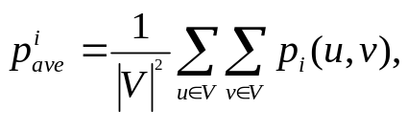

where p_{i}(u,v) is the shortest path between vertices u and v in MST_{i}.
1
4
3
2
9
12
11
10
5
7
6
8
14

13
16
15

b)The following functions operate very similarly as the depth first search. In fact, the only difference is the printf functions in fcn2. Apply them to the graph above! Perform your search regarding the vertices’ ascending numerical order! What is the final output of the algorithm at the end of execution for the above graph?
V₁:1/24 V₂:2/23 V₃:3/22 V₄:4/21
V₅:5/20 V₆:6/19 V₇:7/18 V₈:8/17
V₁₃: 9/16 V₁₄: 10/15 V₁₅:11/14 V₁₆: 12/13
V₉: 25/32 V₁₀:26/31 V₁₁:27/30 V₁₂:28/29

fcn1(G) {
initialize all vertices;
for each vertex u∈V[G] {
status[u]=undetected;
}
for each vertex u∈V[G]
if (status[u]==undetected)
fcn2(u);
}

fcn2(u) {
status[u]=detected;
time++;
d[u]=time;
printf("V%d:%d ",ID[u],d[u]);

for each v ∈ Adj[u]
if (status[v] == undetected) {
fcn2(v);
}
status[u]=processed;
f[u]=time++;
printf("V%d:%d ",ID[u],f[u]);
}

Q4. (5+15=20pts) (2015) (HOMEWORK)
Consider the digraph below!
|V|/4
|V|/4
|V|/4
|V|/4

Each subgraph has a quarter of all vertices in the set of vertices V. Each subgraph is internally fully connected and each subgraph i is connected to a neighbor subgraph j through an edge e_{ij}=(v_{i},v_{j}) where vertices v_{i} and v_{j} are located in subgraphs i and j, respectively. The directions of edges e_{ij}=(v_{i},v_{j}) connecting each pair of neighbor subgraphs are as shown in the figure.
- How is this digraph connected? Explain why!
Weakly connected. For instance, vertices at the leftmost subgraph are not accessible from any other subgraphs.
- Assuming uniformly weighted edges in all subgraphs (i.e., w(u,v)=1 for all existing edges e(u,v)), find one of the MST_{k}s of the underlying graph of the above graph?
Suppose |V|=n.
1
n/4
n/4-1

3n/4+1
n
n-1

n/4+1
2n/4
n/2-1
(2n/4)+1
3n/4
3n/4- 1

Q5. (15 pts each) (2010)
- Find the minimum spanning tree of the graph G below using
- Prim’s algorithm
- Kruskal’s algorithm.
- Are multiple MSTs possible for a graph?Justify you answer on this graph.
Show the tree(s) at each step!
a
b
c
d
e
f
g
h
5
4
12
8
6
4
3
2
1
3
5
6
2
5
4
1

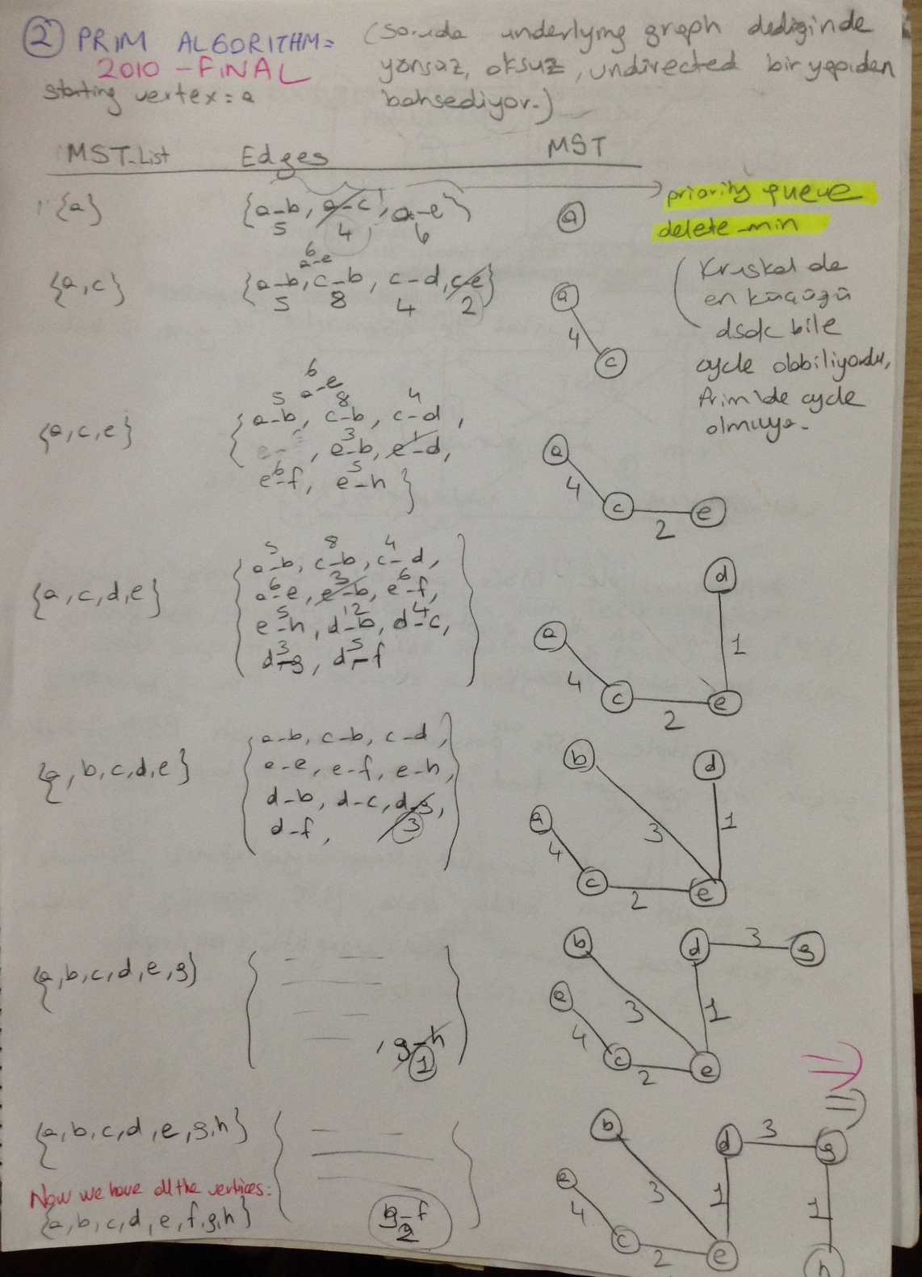

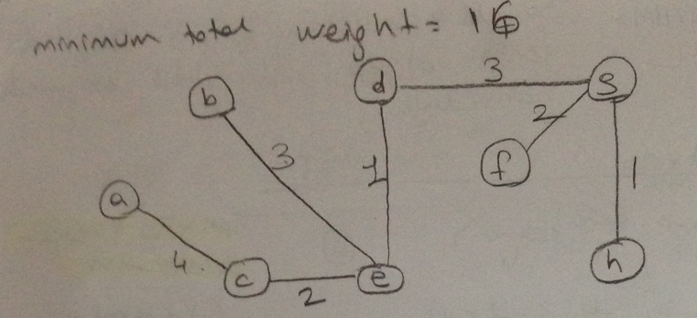

b)Kruskal Alg:

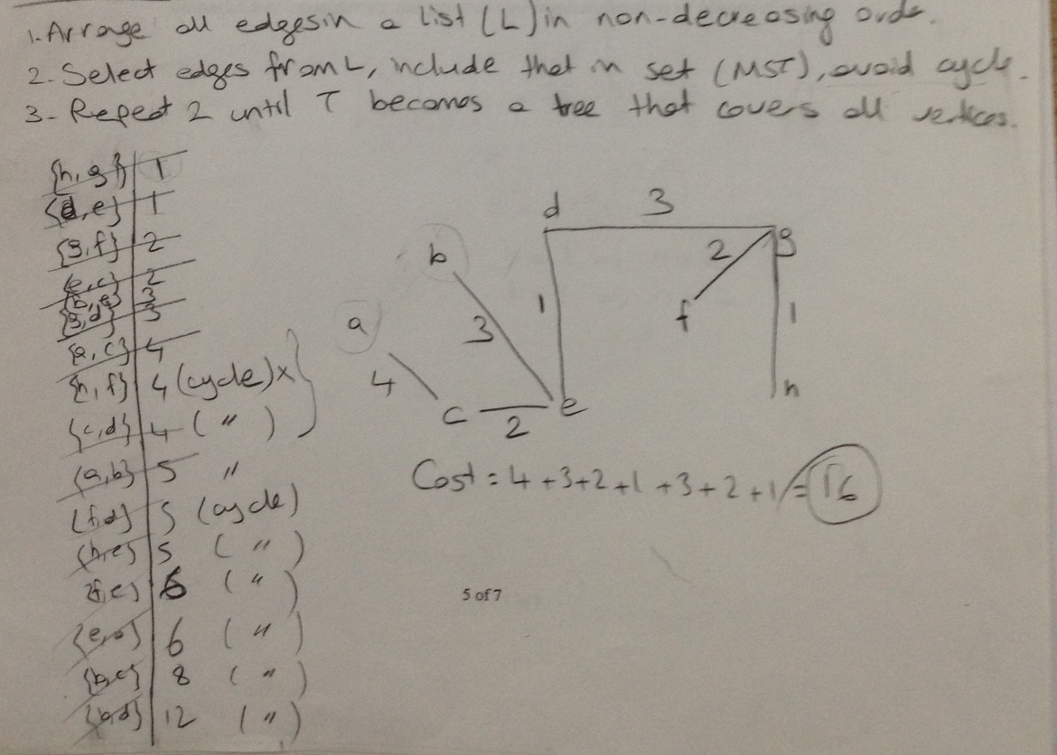

c)Yes multiple MST are possible for a graph. For this graph there is no other MST.

HOMEWORK:

Solve the same question for the graph given in Question 6. Find the MST for the graph given in question 6 by using Prim’s algorithm, Kruskal’s algorithm. Are multiple MSTs possible for a graph?Justify you answer on this graph. (You will se multiple MST scan be possible for a graph.)
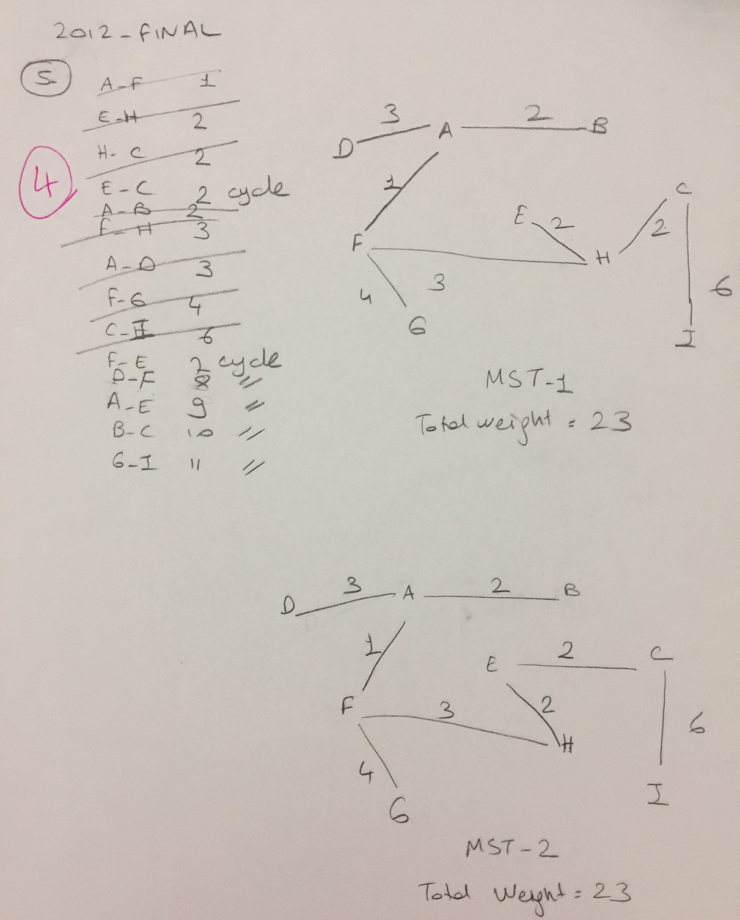

Q6. Shortest path (2012) (20 pts)

Find the shortest paths from node D to other nodes, using Dijkstra Algorithm.

